Should be popup

From main page menu.

Branch Creation

Log out

Successful login

Login Page

FD

Define

Savings Define

Customer Information

User Creation

Main Page

GL

**List Of Pages**

1. Customer Details
2. Branch Creation
3. User Creation
4. User Role define
5. Main GL
6. Sub GL
7. Micro GL
8. Savings Define
9. FD Define
10. Savings Opening
11. FD Opening
12. Transaction Page
13. Vouchers

1)Login Page - username,password,background image,login button,cancel button

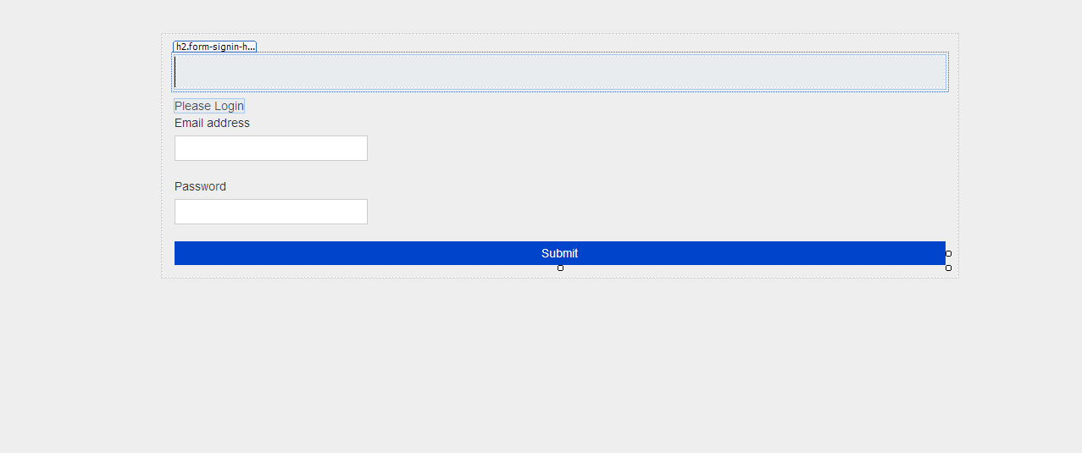

2)Main Page

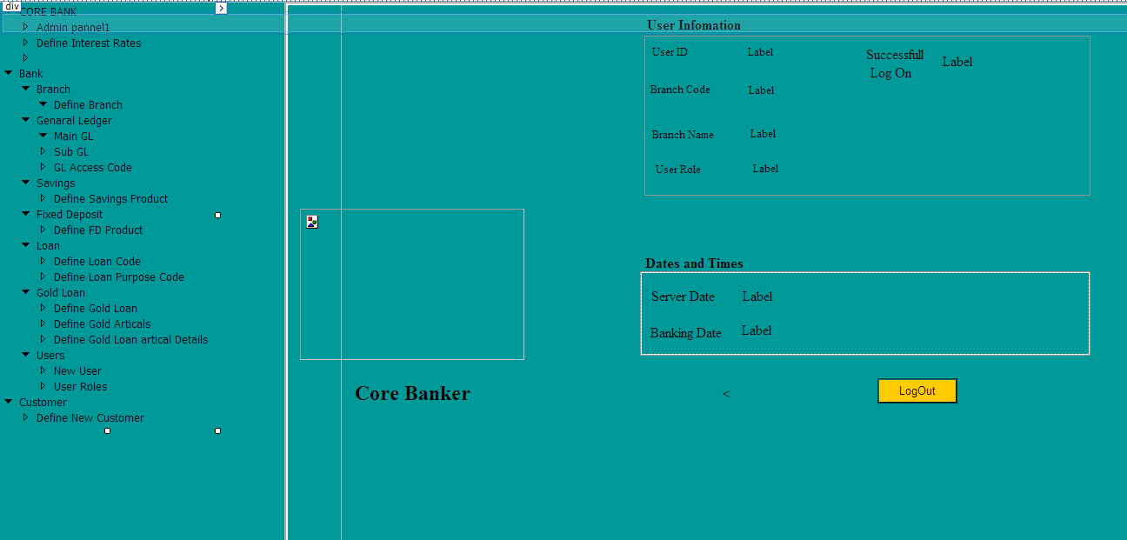

4)User Creation

Need to add branch code and branch name

General Information Tab: 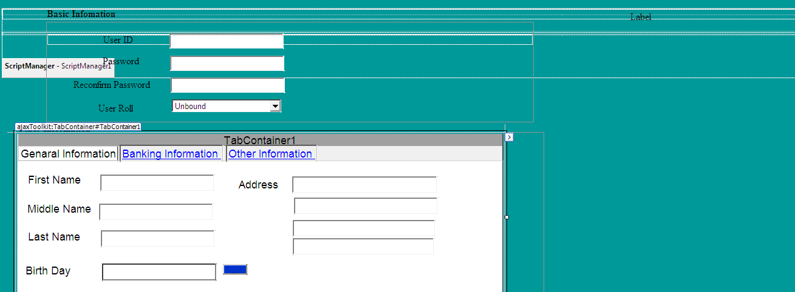

Banking Information Tab: Need to add Post

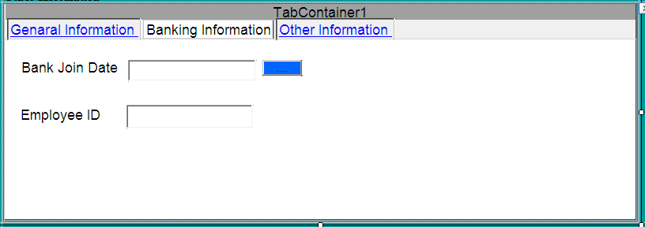

Other Information

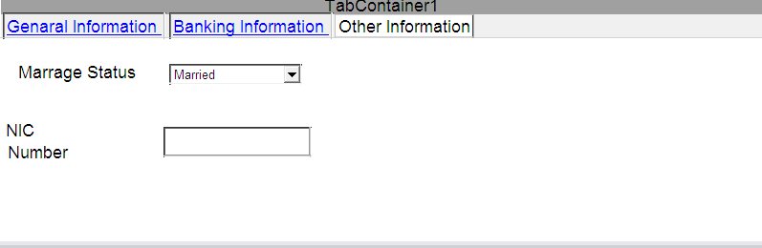

Buttons:

Save /Cancel/ Edit/Remove(*admin rights)